Pure Versus Partial Ecommerce
- Pure vs. Partial EC: based on the degree of digitization of
  - Product
  - Process
  - Delivery agent
- Traditional commerce: all dimensions are physical
- Pure EC: all dimensions are digital
- Partial EC: all other possibilities include a mix of digital and physical dimensions

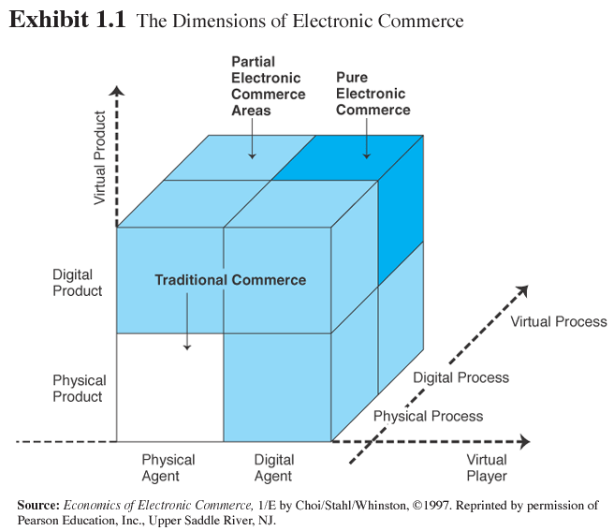
M-Commerce:
M-commerce (mobile commerce) is the buying and selling of goods and services through wireless handheld devices such as cellular telephone and personal digital assistants (PDAs). Known as next-generation e-commerce, m-commerce enables users to access the Internet without needing to find a place to plug in

Mobile e-commerce (m-commerce) can also be define as online sales transactions that use wireless electronic devices such as hand-held computers, mobile phones or laptops. These wireless devices interact with computer networks that have the ability to conduct online merchandise purchases

Advantages of M-commerce
Completely Customization: the service provider has access to data about the user’s preferences and status which facilitates better, personalized service. In addition, the service provider can be constantly updated about the current status and location of the customer so that the service can be customized; for instance, a request for a certain product can be met with the nearest possible source.
More Convenience: the small size and ease of use of mobile receivers, coupled with freedom from problems caused by infrastructure, makes for a higher degree of user convenience.
Expanded reach: the presence of a wireless link between the customer and the service provider eliminates the need for a fixed interface such as a computer for communication. Providers of e-commerce services can therefore reach customers over a longer range, creating the opportunity for new value added services.
Quicker access: connecting through a mobile is faster than dial-up connections using wire line modems.
Electronic wallet:Analysts believe that easy mobile payment is one of the main prerequisites for the success of m-commerce, When the mobile phone can function as an electronic wallet for mobile payments, including micropayments, application developers and service providers will find it attractive to introduce new mobile communication services to the market.
Advantages of wireless technology used in m-commerce
Ubiquity: The use of wireless device enables the user to receive information and conduct transactions anywhere, at anytime.
Accessibility: Mobile device enables the user to be contacted at virtually anytime and place. The user also has the choice to limit their accessibility to particular persons or times.
Convenience: The portability of the wireless device and its functions from storing data to access to information or persons.
Localization: The emergence of location-specific based applications will enable the user to receive relevant information on which to act.
Instant Connectivity (2.5G): Instant connectivity or "always on" is becoming more prevalent will the emergence of 2.5 G networks, GPRS or EDGE. Users of 2.5 G services will benefit from easier and faster access to the Internet.
Personalization: The combination of localization and personalization will create a new channel/business opportunity for reaching and attracting customers. Personalization will take the form of customized information, meeting the users’ preferences, followed by payment mechanisms that allow for personal information to be stored, eliminating the need to enter credit card information for each transaction.
Time Sensitivity: Access to real-time information such as a stock quote that can be acted upon immediately or a sale at a local boutique.
Limitations of m-commerce:
Lack of Standards:
• With a host of device operating systems and platforms, middleware solutions and networks, make application development for the wireless Internet a formidable task, versus the level operating environment of the wired Web.
• Even though efforts are underway to standardize the operating environment, especially in North America, where standardization is most lacking, companies will have to work within this scattered environment, at least in the short –term.
Device Constraints:
• Weak processors
• Limited memory
• Tiny screens, poor resolutions
• Poor data entry
WAP: While WAP has been a very important in the evolution of the wireless Internet and in turn m-commerce, there are problems/difficulties with the standard, such as the lack of WAP-enabled devices and security issues.
Networks:
Current data speeds between 9.6-14.4 kbps are too, expensive vs fixed.
Services:
M-commerce has flopped in the consumer arena -- or at least has failed to live up to the hype. There may be compelling reasons for business users to adopt transaction-based services offered on wireless devices, though -- but the mobile commerce tools used by enterprises are nothing like the services pitched to consumers.

U-Commerce:
Ubiquitous = represents the ability to be connect at any time and in any place as well as the integration of human-computer interaction into most devices and processes, e.g. household objects.
Ubiquitous Commerce also known as U-Commerce, u commerce or uCommerce, refers to a variety of goods and/or services. Sometimes, it is used to refer to the wireless, continuous communication and exchange of data and information between and among retailers, customers, and systems (e.g., applications) regardless of location, devices used, or time of day.

The ultimate form of e-commerce and m-commerce in an ‘anytime, anywhere’ fashion. It involves the use of ubiquitous networks to support personalized and uninterrupted communications and transactions at a level of value that far exceeds traditional commerce.

